**IDEAL FLOW NETWORK EDITOR**

USER GUIDE  
VERSION 1.0

**Developed by:**   
Ateneo Pedestrian and Traffic Computing Laboratory

**Research Assistants:**  
Rina Carines M. Cabral

Contents

Editor Parts 2

Tool Bar 2

Editor Canvas 2

Networks Panel 3

Information Panel 3

Navigation 4

Creating Networks 4

Adding Networks 4

Activating Network 4

Adding Nodes 5

Adding Links 6

Moving Elements 6

Deleting Elements 8

Assigning and Removing Elements in a Network 9

Viewing and Editing Properties 11

Node Information 11

Link Information 13

Network Information 14

# Editor Parts

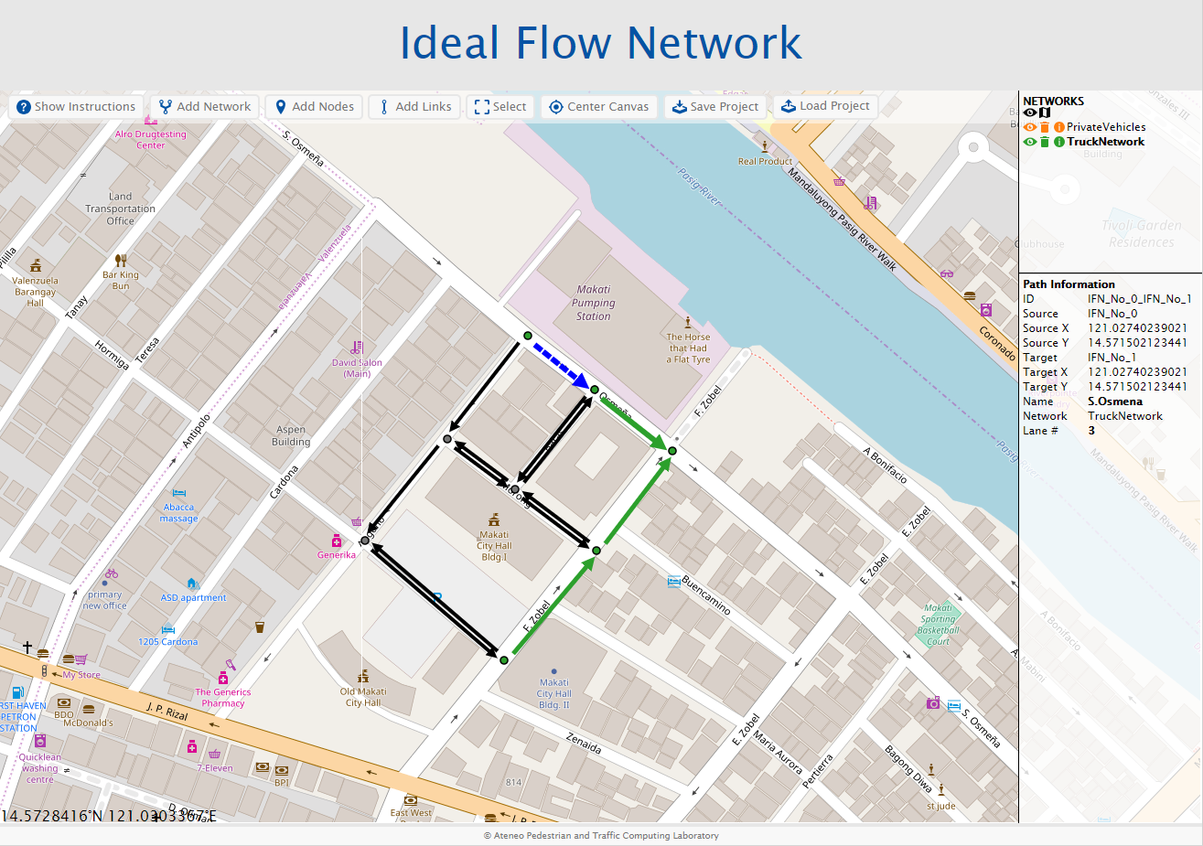

Editor Canvas

Information Panel

Networks Panel

Tool Bar

Tool Bar

1. Show Instructions – toggles quick guide panel
2. Add Network – adds a new layer on the networks panel
3. Add Nodes – adds nodes to the canvas
4. Add Links – adds links to the canvas
5. Select – allows user to select nodes and links to move, delete or assign to networks
6. Center Canvas – centers the canvas view to the geographic middle of all current data
7. Save Project – compiles all the data on the canvas and saves everything into a json project file
8. Load Project – loads project files into the canvas

## Editor Canvas

Shows all the nodes and links of the project.

|  |  |
| --- | --- |
|  | Regular node & link |
|  | Selected node/link for information. Information about the selected node/link is displayed on the information panel |
|  | Selected for move, delete or assign |
|  | Network assigned nodes and links. Each color represents as different network. |

## Networks Panel

Lists all the networks in the project.

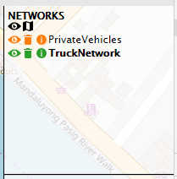The maximum number of networks the editor can hold is 10.

|  |  |
| --- | --- |
|  | Hides all (black) or individual (colored) networks |
|  | Shows all (black) or individual (colored) networks |
|  | Deletes the specific network |
|  | Shows the information of a specific network on the information panel |
|  | Hides the network information in the information panel |
|  | Adds/Assigns the selected nodes and links to the specific network |
|  | Removes the selected nodes and links to the specific network |
|  | Hides the map |
|  | Shows the map |

## Information Panel

Displays all the information of the selected node/link/network. These could be customized on the javascript code based on the needs of the project.

The maximum number of details that could be displayed is 25 due to space limitation.

**Network**

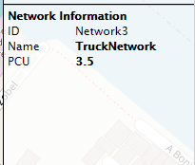

**Link**

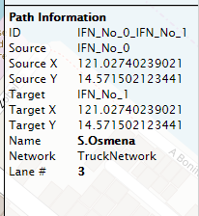

**Node**

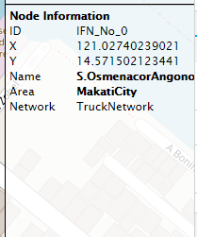

# Navigation

* Drag the canvas to pan the map.
* Use the mouse wheel to zoom in and out
* Double click will also zoom in.
* Click **Center Canvas** to center the current data to the view
* Hold *Shift Key* and drag across the canvas to activate the zoom rectangle. The canvas will zoom and center on the center of the created rectangle.

# Creating Networks

The editor starts as a blank canvas with one default network named ***Network1***. This network can be deleted if loading a project file. All nodes and links must belong to a network, however, so the buttons **Add Node** and **Add Link** are disabled when a network is not selected.

## Adding Networks

1. On the Tool Bar, click **Add Network** button.
2. A new network will be added on the Networks Panel named ***Network#*** with a different color assigned to it*.* The number is incremental based on the number of networks that were added to the editor. All nodes and links added to this network will reflect its assigned color.
3. 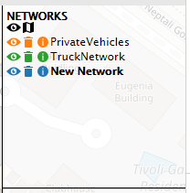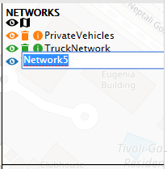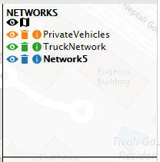To rename the network, double click the network name and an input box will show. Type in the new name and press *Enter* to save the name.

## Activating Network

Nodes and links can only be added to an active network. An active network is shown on **bold text** on the Networks Panel. Clicking on a network name will activate the network. All of the nodes and links added while it is active will be assigned to it. Activating a network will also highlight all the nodes and links assigned to it.

On the following example, the network **New Network** still doesn’t have any nodes/links assigned to it so no nodes/links changes color when it is activated. The right example however, **TruckNetwork** has 5 nodes and 4 links already assigned to it so they appear in the network’s assigned color.

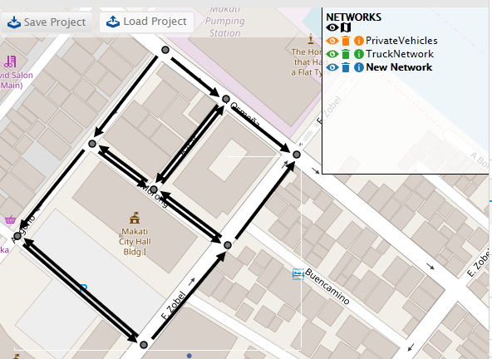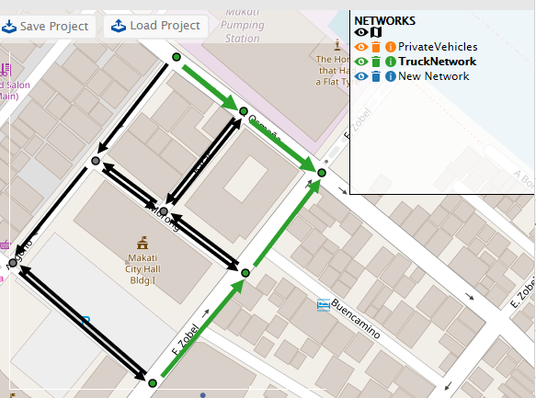

## Adding Nodes

1. Select/Activate the network where you want to add nodes to.
2. On the Tool Bar, click **Add Node** button.
3. Navigate through the map and click the location where the node should be placed. New nodes will be added on the color of the activated network.
4. Click **Done** button on the Tool Bar when done adding nodes.

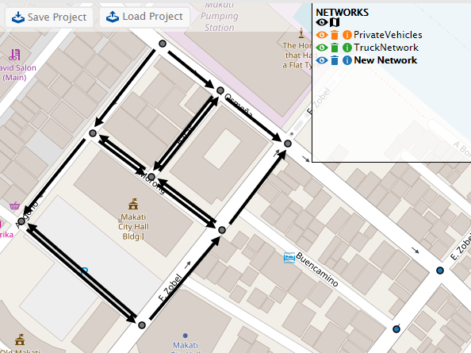

## Adding Links

1. Select/Activate the network where you want to add nodes to.
2. On the Tool Bar, click **Add Link** button.
3. Navigate through the map and locate the nodes that need to be linked.
4. Since links are directional, click and dragfrom the source node to target node. An arrow will appear as the cursor is being dragged.
5. After adding all the needed links, click **Done** on the Tool Bar.  
   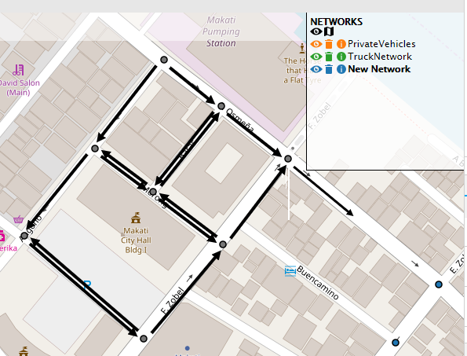 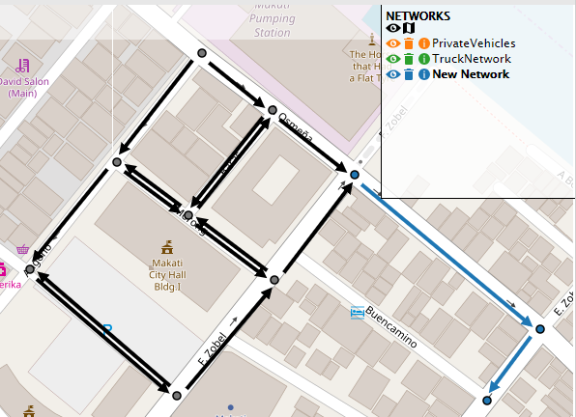

# Moving Elements

Only nodes could be moved. All links attached to a moved node will move with the node.

1. On the Tool Bar, click **Select**.
2. Select the node that should be moved. It will show as a big red node.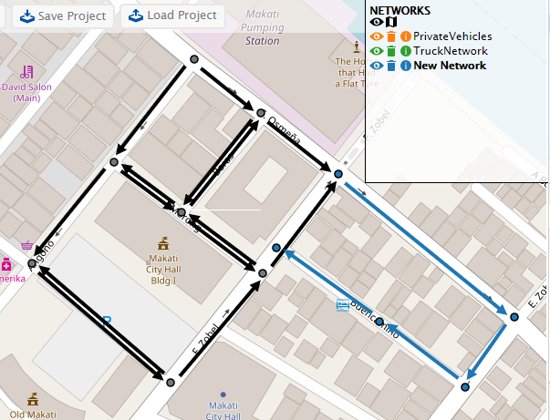 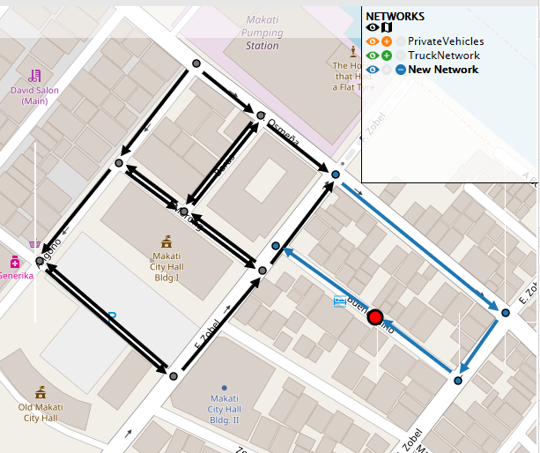
3. Drag the node and all the links connected to it will move with it.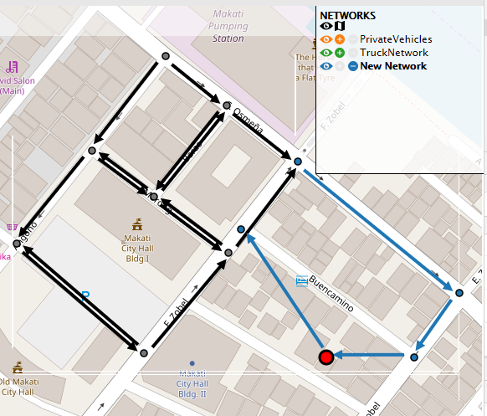
4. Selecting multiple nodes will anchor them together as they are being moved. Clicking a selected node will deselect it and remove it from the anchor. The remaining selected nodes can still be moved together.  
   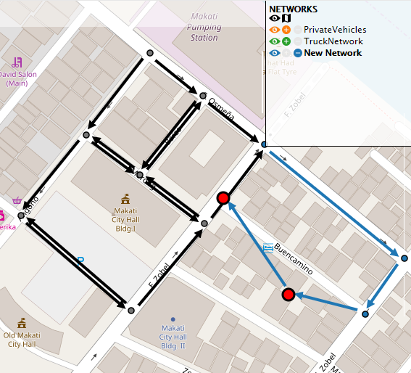 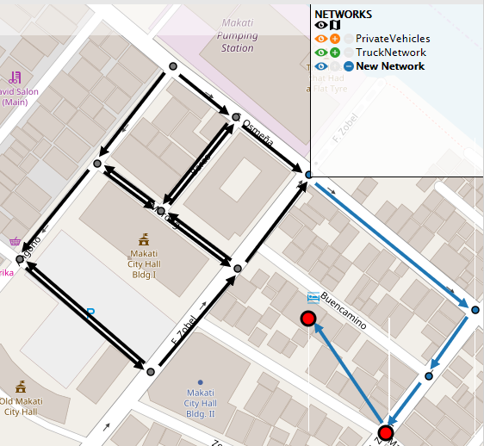

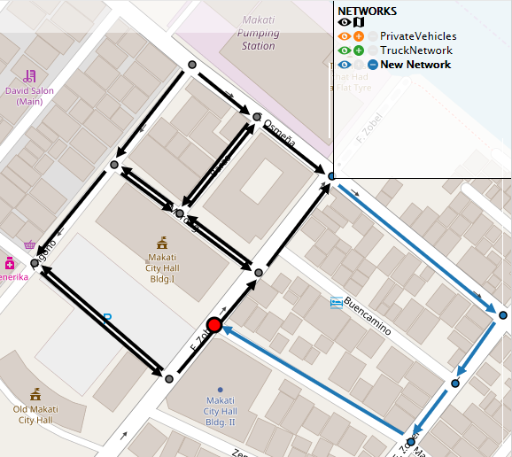 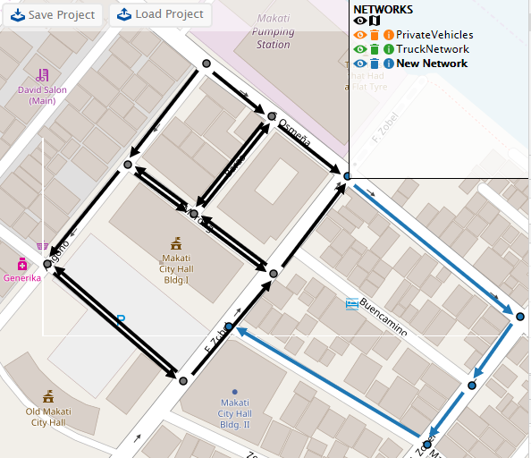

# Deleting Elements

1. On the Tool Bar, click the **Select** button.
2. Select the node/s and/or link/s to be deleted. A selected node will appear bigger and red. A selected link will be red and dashed.  
   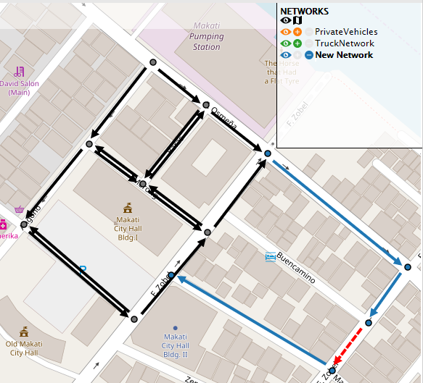 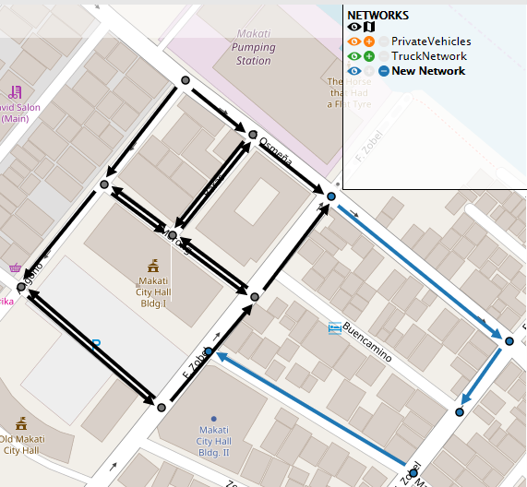
3. Deleting a node will automatically delete all the links connected to it. 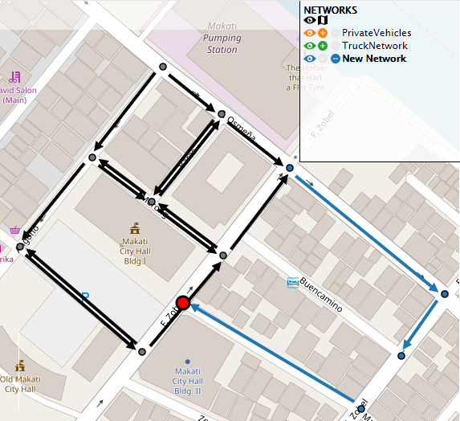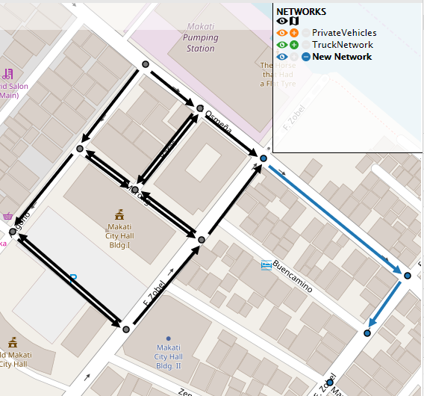
4. Selecting multiple nodes and links will delete them all together including all links connected to all the nodes.  
   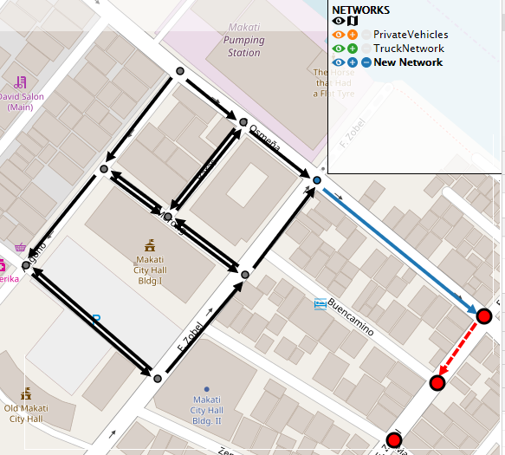 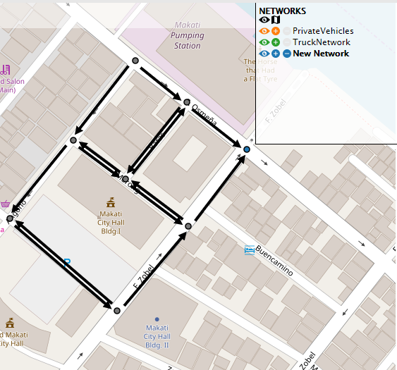
5. Click **Done**, on the Tool Bar when finished.

# Assigning and Removing Elements in a Network

Nodes and links can belong to multiple networks.

1. On the Tool Bar, click the **Select** button.
2. Select the node/s and/or link/s that you want to assign to a network. The **+** button beside the network will highlight if at least one of the selected elements are not yet in that network. The **–** button will highlight if at least one of the selected elements are already in that network.
3. Clicking the **+** button will add the selected elements to the network. If a link is selected, both the source and target nodes will also be added to the network.  
   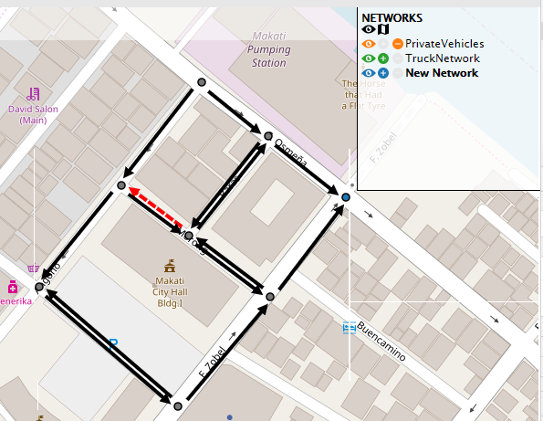 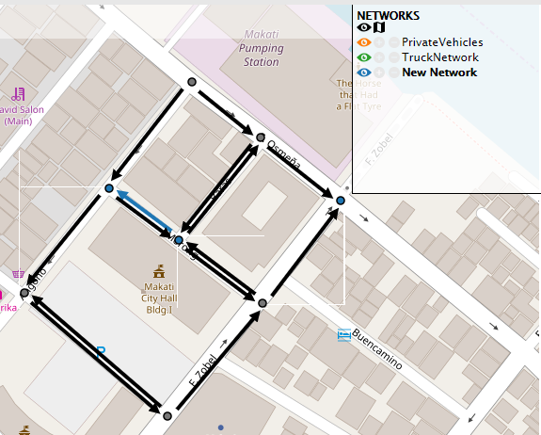

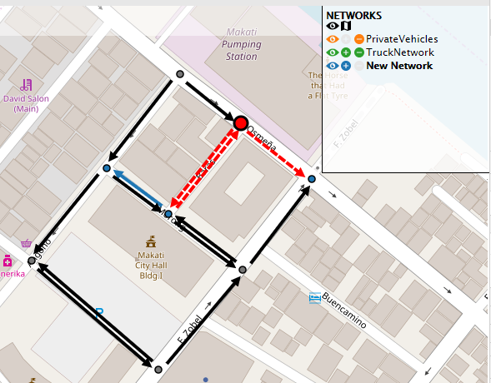 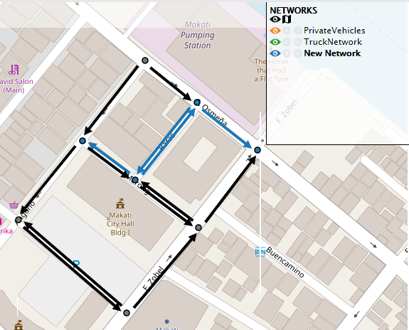

1. Clicking the **–** button will remove the selected elements from the network. Removing a node from a network will also remove all the links that are connected to it from the network.

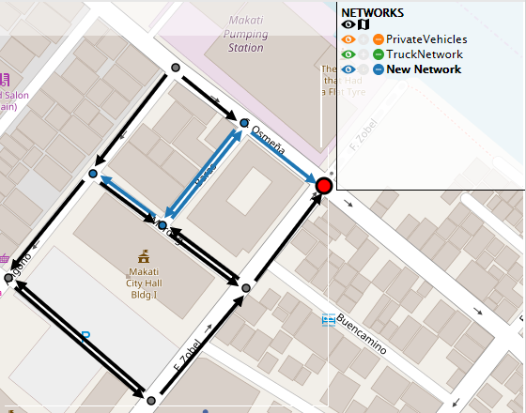 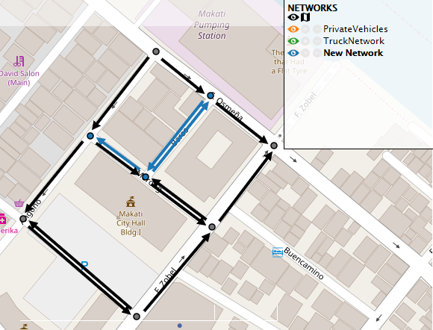

# Viewing and Editing Properties

## Node Information

1. 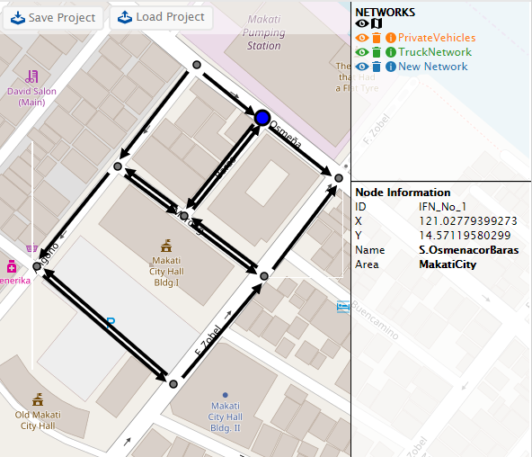**Viewing** - Without having the Select button activated, click a node on the canvas. It will appear bigger and blue. The information panel will appear displaying all the details of the node. If the node belongs to one or more networks, those networks will highlight on the network panel with their assigned color.   
     
   If no network is activated, only the node information will be displayed.  
     
   If a highlighted network is activated, the network name will be added on the information panel as well as network node specific information. That is, details about the node that differs between networks.  
     
   The node on the example given belongs to all the 3 networks currently in the project. Activating the networks separately, the network node information changes each time. However, there are no network specific information for the node, so only the network name changes for this example.  
   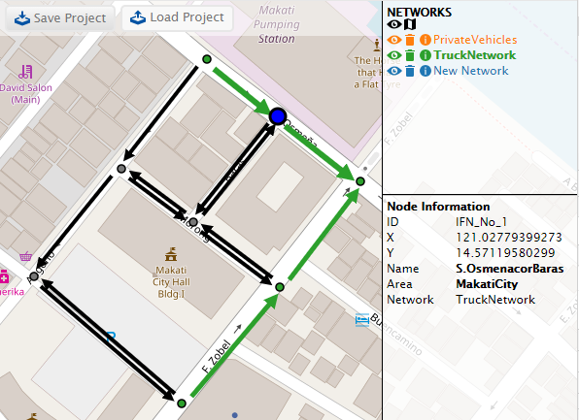 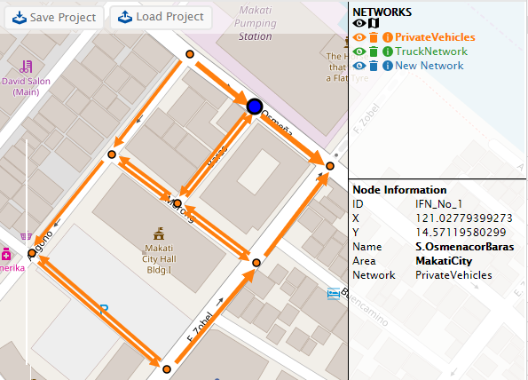 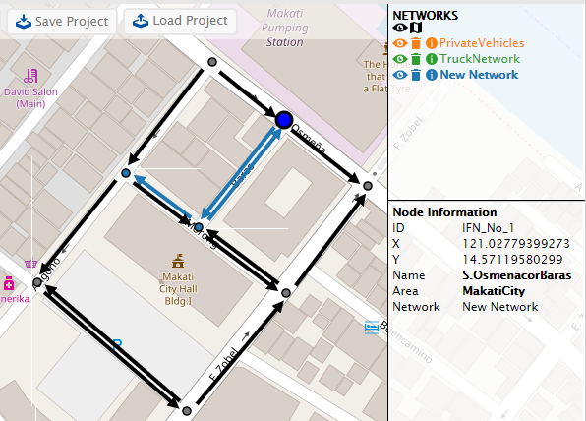
2. **Editing** – information that can be edited on the information panel are shown in **bold letters.** Double clicking the value will show an input box. Type in the new value and hit ***Enter***to save the new information.  
   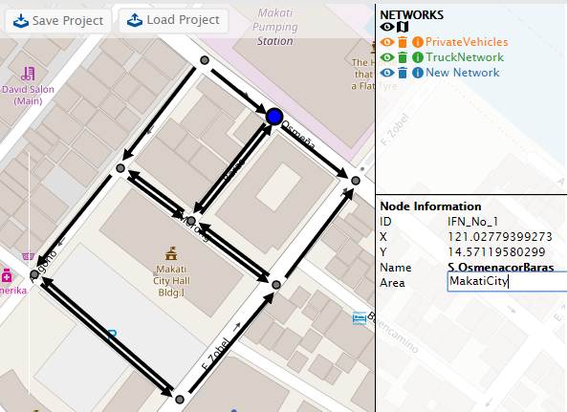 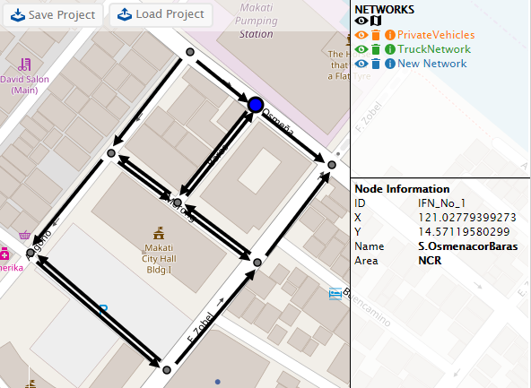   
     
   Changing a node property will be saved on the node itself. Switching active networks will reflect this change for all networks the node is in.  
   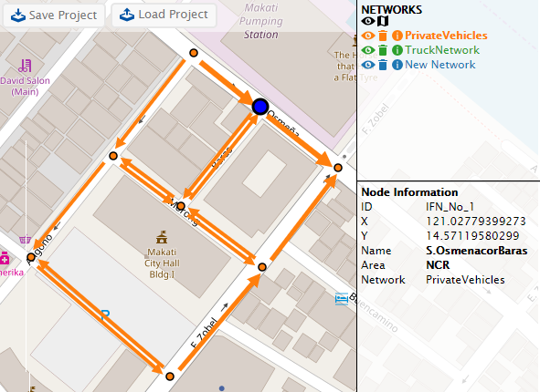 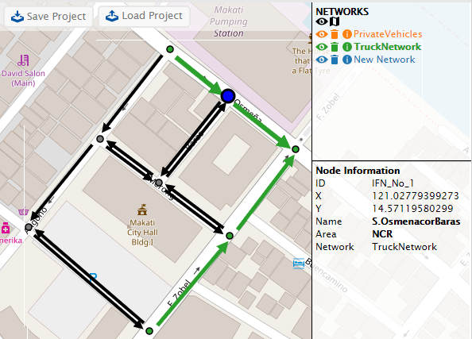   
     
   Changing a network node property will only change the value for that particular networkso activating a different network will reflect different values on the information panel. However, the example given doesn’t have any network node properties so it cannot be shown with these. Editing network specific information will be demonstrated further on with network links on the next section.

## Link Information

1. 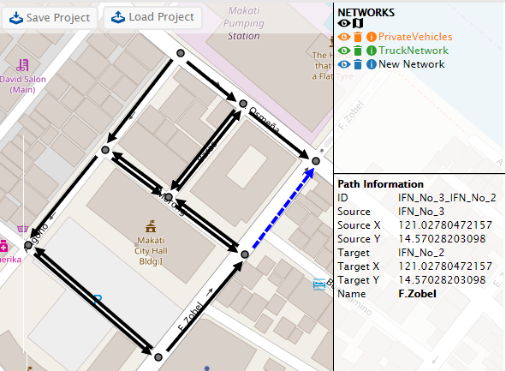**Viewing** - Viewing link information is the same as viewing node information. Without having the Select button activated, click on a link on the canvas. It will appear blue and dashed. The information panel will appear with link details. If the link belongs to one or more networks, those networks will highlight on the network panel with their assigned color.  
     
   If no network is activated, only the link information will be displayed.  
     
   For this example, the selected link is only associated with the first 2 networks so only 2 are highlighted.  
     
   If a highlighted network is activated, the network name will be added on the information panel as well as network link specific information. That is, details about the link that differs between networks.
2. **Editing**  - information that can be edited on the information panel are shown in **bold letters.** Double clicking the value will show an input box. Type in the new value and hit ***Enter***to save the new information.  
     
   As with nodes, changing link information will reflect for all the networks that it is assigned to.  
   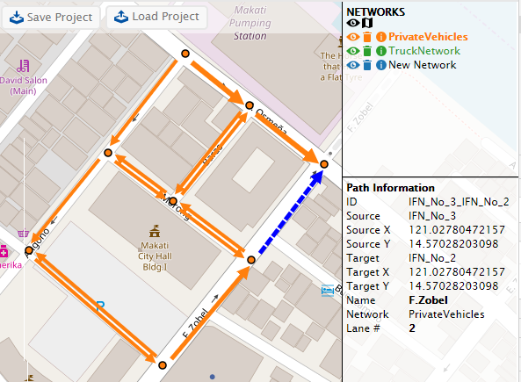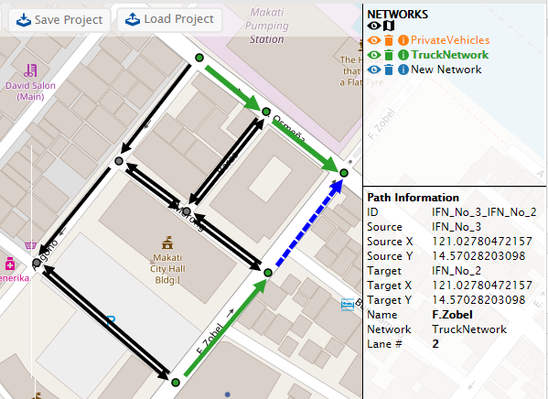  
     
   Changing network link information will only be saved for that particular network. For the example below, **Lane #** is a network link property. Changing the property on one network will not affect the Lane# on the other network.  
     
   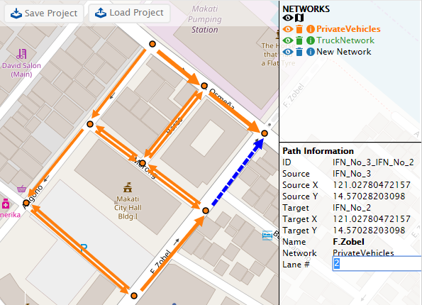 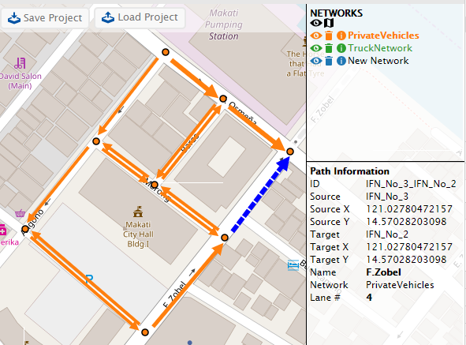 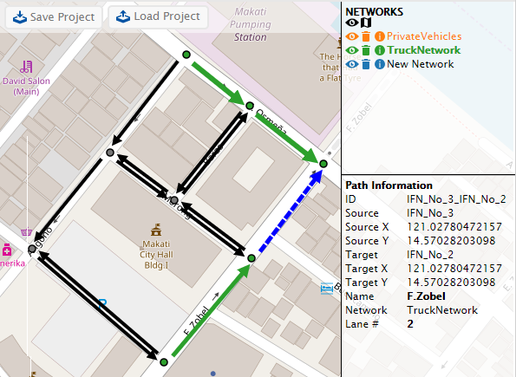

## Network Information

1. 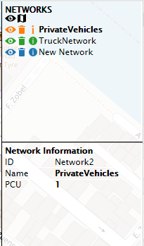Click the **i** button beside the network to be viewed. Network details will show on the information panel.
2. Details that can be edited will appear as **bold letters.** Double click on the information and an input box will appear. Type in the new information and hit ***Enter*** to save.
3. To hide the network information, click the **i** button again.